**Structure of atom**

**“All things are made of atoms—little particles that move around in perpetual motion, attracting each other when they are a little distance apart, but repelling upon being squeezed into one another." - Richard Feynman**

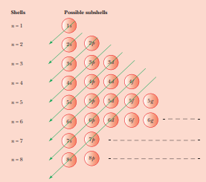

After studying this unit you will be able to

* know about the discovery of electron, proton and neutron and their characteristics;
* describe Thomson, Rutherford and Bohr atomic models;
* understand the important features of the quantum mechanical model of atom;
* understand nature of electromagnetic radiation and Planck's quantum theory,
* explain the photoelectric effect and describe features of atomic spectra;
* state the de Broglie relation and Heisenberg uncertainty principle;
* define an atomic orbital in terms of quantum numbers;
* state Aufbau principle, Pauli exclusion principle and Hund's rule of maximum multiplicity; and
* write the electronic configurations of atoms.

The existence of atoms has been proposed since the time of early Indian and Greek philosophers (400 B.C.) who were of the view that atoms are the fundamental building blocks of matter. According to them, the continued subdivisions of matter would ultimately yield atoms which would not be further divisible. The word 'atom' has been derived from the Greek word 'a-tomio' which means 'uncut-able' or 'non-divisible'.

Dalton’s theory offered logical explanation of many experimental observations and laws that were known at the time, such as – the law of conservation of mass, law of constant composition and law of multiple proportions. It, however, failed to explain certain observations about properties of materials, such as the ability of glass or ebonite rod to generate electricity when rubbed with silk or fur. Now we know that, atoms are not quite as indestructible as Dalton had postulated. During the late 1800s and early 1900s, experiments were performed which demonstrated that atoms are composed of subatomic particles like electrons, protons and neutrons.

Emerging studies of particles, such as electrons, passing through very small openings gave results (diffraction patterns) that could only be explained if we regarded particles as waves. This led to the concept of the wave–particle duality of matter and energy. The above problems with classical physics made it clear that an entirely new set of concepts would be needed to define modern physics and chemistry. These concepts are commonly called wave mechanics, quantum mechanics, or quantum theory and they are now a cornerstone of modern chemistry.

**Discovery of Sub-atomic Particles**: An insight into the structure of atom was obtained from the experiments on electrical discharge through gases. Before we discuss these results we need to keep in mind a basic rule regarding the behavior of charged particles: “Like charges repel each other and unlike charges attract each other”.

**DISCOVERY OF ELECTRON**: In the later part of the nineteenth century, scientists began to experiment with glass tubes in which a high-voltage electric current was passed through a gas at low pressure. Under ordinary conditions, gases are poor conductors of electricity, however when a high voltage is applied to them at low pressure, the gases behave as conductors and current flows through them in the form of rays, which interact with the glass tube and cause the glass tube to glow. This flow of electricity is called an **electric discharge**, and so the tube is called **discharge tube**. The existence of these rays was studied first by **William Crookes** in 1879 using discharge tube, which is a long glass tube, sealed at both the ends and fitted with two metal electrodes. It is also known as **Crookes tube**. The tubes are connected to a vacuum pump which is used to reduce the pressure of gas in the tube.

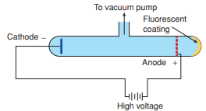Tests soon revealed that these rays were, in fact, negatively charged particles moving from the negative electrode (the cathode) to the positive electrode (the anode). It was Benjamin Franklin who decided which electrode was positive and which was negative. These rays were called emissions rays, and because the rays came from the cathode, they were called cathode rays. If a hole is made in the anode, the fow of the current from cathode to anode may be checked. If the tube behind the anode is coated with zinc sulphide, then a bright spot on the coating is developed.

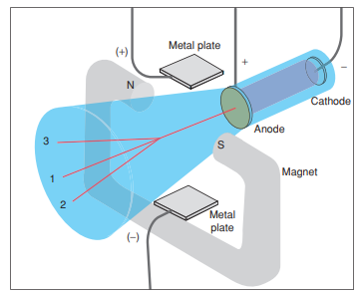**Thomson Experiment - Determination of Mass to Charge Ratio:**

In 1897, the British physicist J.J. Thomson constructed a special cathode ray tube to make quantitative measurements [the ratio of electrical charge (e) to the mass of electron (m,)] of the properties of cathode rays. In some ways, the cathode ray tube he used was similar to a TV picture tube. In Thomson's tube, a beam of cathode rays was focused on a glass surface coated with a phosphor; this surface glows when the cathode rays strike on it. The results of these experiments established the following properties of cathode rays:

1. These cathode rays flow from cathode to anode in straight line, unless influenced by electrical or magnetic fields.

2. These rays are not visible as such and can be detected by fluorescent or phosphorescent materials which glow when these rays fall on them.

3. That cathode rays are negatively charged. This can be proved since they behave like negatively charged particles under the influence of electric and magnetic fields.

4. The experiments performed using the cathode ray tube demonstrated that cathode ray particles are in all matter. They are, in fact, electrons. The properties of electrons are independent of electrode material and nature of the gas.

5. Cathode rays are made up of material particles and this was demonstrated by the fact that they could rotate the light paddlewheel mounted on an axle.

6. When the cathode rays strike the metal foil, it becomes heated, showing that cathode rays produce heating effect.

7. They show penetrating effect and ionize the gas through which they pass. This property is exploited in making television sets containing cathode ray tubes.

The cathode ray beam passed between the poles of a magnet and between a pair of metal electrodes that could be given electrical charges. When electrical or magnetic fields are applied perpendicular to the path of charged particles, they deviate from their path and the amount of deviation depends on:

1. The magnitude of charge on the particle. Greater the magnitude of charge, greater is the interaction with the field, and hence higher is the deviation.

2. The mass of the charged particle. Heavier particles are deviated to a lesser extent.

3. The strength of the magnetic field or the voltage applied across the path of the charged particles.

The magnetic field tends to bend the beam in one direction (see property 2) whereas the charged electrodes bend the beam in the opposite direction (see property 3). By adjusting the charge on the electrodes, the two effects can be made to cancel, and from the amount of charge on the electrodes required to balance the effect of the magnetic field, Thomson was able to calculate the first bit of quantitative information about a cathode ray particle - the ratio of its charge to its mass as

1.75882 × 1011 Ckg-1 where the coulomb (C) is a standard unit of electrical charge. The particles are negatively charged so the charge on the electron is -e. Therefore,

= 1.75882 × 1011 Ckg-1

where is the mass of the electron.

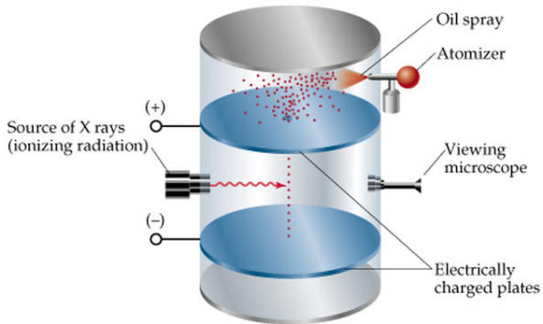

**Millikan Oil Drop Experiment - Charge on an Electron:**

In 1909, Robert Millikan, a researcher at the University of Chicago, designed an experiment in which he sprayed a fine mist of oil droplets above a pair of parallel metal plates, the top one of which had a small hole in it. As the oil drops settled, some passed through this hole into the space between the plates, where he irradiated them briefly with X-rays. The X-rays knocked off electrons from molecules in the air, and the electrons attached to the oil drops, which thereby were given an electrical charge. By observing the rate of fall of the charged drops, both when the metal plates were electrically charged and when they were not, Millikan was able to calculate the amount of charge carried by each drop. When he examined his results, he found that all the values he obtained were whole number multiples of - 1.6 × 10-19 C. He reasoned that since a drop could only pick up whole numbers of electrons, this value must be the charge carried by each individual electron. This concept is called quantization of charge, according to which charge of any particle can be expressed as integral multiple of electronic charge (e).

Thus, **q = n (e**) , where n =... -3,-2,-1,0,1,2,3... and e = 1.6 × 10-19 C

Presently, the accepted value of charge is - 1.6022 × 10-19 C. Once Millikan had measured the electron's charge, its mass could then be calculated from Thomson's charge-to-mass ratio. This mass was calculated to be 9.09 × 10 - 28 g. More precise measurements have since been made, and the mass of the electron is currently reported to be 9.10941 × 10 - 31 kg.

**Discovery of Protons:**

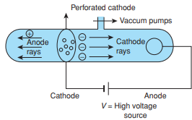Electrical discharge carried out in the modified cathode ray tube led to the discovery of canal rays or anode rays carrying positively charged particles.

Since, penetrating power 1/m, therefore, the positive ions being heavier than electrons were not able to penetrate the cathode. In the ionization of gas, positive ions and electrons were formed. For example, He → He+2 + 2e-

Electrons were detected in cathode rays but positive ions were not as they could not penetrate the cathode. Thus, a new experimental set-up consisting of the perforated cathode was done and the positive ions were now detected on the cathode side of the discharge tube. Theses rays were known as anode rays. They consisted of the positive ions moving with much smaller speeds relative to electrons and were detected by application of electric and magnetic fields.

The **characteristics** of these positively charged particles are listed below.

(i) Unlike cathode rays, mass of positively charged particles depends upon the nature of gas present in the cathode ray tube. These are simply the positively charged gaseous ions.

(ii) The charge to mass ratio of the particles depends on the gas from which these originate.

(iii) Some of the positively charged particles carry a multiple of the fundamental unit of electrical charge.

(iv) The behavior of these particles in the magnetic or electrical field is opposite to that observed for electron or cathode rays.

The smallest and lightest positive ion was obtained from hydrogen and was called **proton** after the Greek word **proteios**, meaning “of frst importance” and was characterized in 1919.

**Discovery of Neutrons:** The estimation of mass of an atom based on the number protons, however, fell short of the actual mass of the atom and could account for only about half of the mass of the atom. This led to the suggestion for presence of another particle in the nucleus with mass close to or equal to that of proton, but was electrically neutral. The identity of these particles was established by British physicist, James Chadwick in 1932, based on some experimental observations of German physicists Walther Bothe and Herbert Becker in 1930. They noticed that when a-rays were beamed at beryllium, it emitted a neutral radiation that could penetrate 200 mm of lead.

Chadwick called these particles neutrons and proved his hypothesis by the following experiment.



**Note:** The research on subatomic particles over the years has shown that protons and neutrons are themselves composed of still smaller particles called quarks. The existence of quarks has led us to understand how the atomic nucleus stays together in spite of the presence of positively charged particles in close proximity. Quarks are, however, unstable outside the confines of the nucleus. Many other subatomic particles, such as mesons, positrons, neutrinos and antiprotons have been discovered, but it is not yet clear whether all these particles are actually present in the atom or whether they are produced by reactions occurring within the nucleus. The fields of atomic and high-energy physics have produced a long list of subatomic particles.

**Atomic Models:**

Scientists such as Thomson, Rutherford, Becquerel, Curie and Roentgen and others have contributed to the current model of the atom and explained the distribution of charged particles within the atom. Two of these models proposed by Thomson and Rutherford are discussed as follows.

**Thomson Model of Atom**: In 1898, Thomson proposed a model of the atom in which, the electrons are negatively charged particles embedded in the atomic sphere of approximate radius 10−10 m. Since atoms are electrically neutral, the sphere also contains an equal number of positive charges. The positive charge was assumed to be spread throughout the atom, forming a kind of pudding in which the negative electrons were suspended like plums, hence the **name plum pudding model**. The mass of the atom is thus assumed to be distributed uniformly over the atom.

**Note:** The model is also known **watermelon model** because an atom could be visualized as a watermelon of positive charge with electrons as seeds embedded in it.

**Drawback:** The model proposed by Thomson could explain the neutrality of an atom, but could not account for results for later experiments by Rutherford about distribution of mass.

**Rutherford’s Nuclear Model of Atom:**

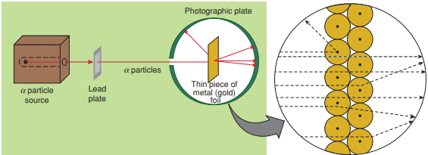Rutherford and his students (Hans Geiger and Ernest Marsden) bombarded very thin gold foil with α–particles- **Rutherford’s famous α –particle scattering experiment**. A stream of high energy

α–particles from a radioactive source was directed at a thin foil (thickness ∼ 100 nm) of gold metal. The thin gold foil had a circular fluorescent zinc sulphide screen around it. Whenever α–particles struck the screen, a tiny flash of light was produced at that point.

Based on the Thomson's model of the atom, Rutherford expected α particles to pass straight through the foil, since electrons with small mass could not deflect them and the positive charge was spread uniformly in the atom.

It was observed that:

(i) most of the α–particles passed through the gold foil undeflected.

(ii) a small fraction of the α–particles was deflected by small angles.

(iii) a very few α–particles (∼1 in 20,000) bounced back, that is, were deflected by nearly 180°.

Rutherford found that he could explain results by assuming that the positive charge and most of the mass of an atom are concentrated in a small fraction of the total volume, which he called the **nucleus**.

Based on this, he explained the experimental observations as follows:

(i) Most of the space in the atom is empty as most of the α–particles passed through the foil undeflected.

(ii) A few positively charged α–particles were deflected. The deflection must be due to enormous repulsive force showing that the positive charge of the atom is not spread throughout the atom as Thomson had presumed. The positive charge has to be concentrated in a very small volume that repelled and deflected the positively charged α–particles.

(iii) Calculations by Rutherford showed that the volume occupied by the nucleus is negligibly small as compared to the total volume of the atom. The radius of the atom is about 10–10 m, while that of nucleus is 10–15 m. One can appreciate this difference in size by realising that if a cricket ball represents a nucleus, then the radius of atom would be about 5 km.

On the basis of above observations and conclusions, Rutherford proposed the **nuclear model** of atom. According to this model:

(i) The positive charge and most of the mass of the atom was densely concentrated in extremely small region. This very small portion of the atom was called nucleus by Rutherford.

(ii) The nucleus is surrounded by electrons that move around the nucleus with a very high speed in circular paths called **orbits**. Thus, Rutherford’s model of atom resembles the solar system in which the nucleus plays the role of sun and the electrons that of revolving planets.

(iii) Electrons and the nucleus are held together by electrostatic forces of attraction.

* Rutherford was able to estimate the size of the nucleus and according to his calculations, the radius of the nucleus is at least 10,000 times smaller than the radius of the atom. If the radius of the atom is about 10−10 m, then the radius of the nucleus is 10−14 m.

**R = R0**

Where R is the radius of the nucleus, **R0**= 1.33×10-5 and A is the mass of the atom.

**Drawbacks of Rutherford Model:**

The nuclear model proposed for the atom by Rutherford can be visualized as a small-scale solar system in which the nucleus (heavy) is like the sun in the center with electrons (lighter) revolving around in orbits like planets. This model of the atom works reasonably well in fact, it continues to be used to visualize a variety of chemical concepts. However, there are several drawbacks associated with this atomic model proposed by Rutherford and these are discussed as follows.



1. It could not explain the **stability** of the atom. According to this model, electrons revolve around the positively charged nucleus in circular orbits. According to Maxwell's classical electromagnetic theory, accelerated charged particles radiate energy. The negatively charged particle must be attracted towards the positively charged nucleus. Due to this attractive force, the radius of the circular path of the electrons must decrease continuously and ultimately the electron should fall into the nucleus in 10s. However, this does not actually happen and electrons do not fall into nucleus. Rutherford's model was not able to explain the stability of atoms.

2. It was not able to explain the **line spectra** for various elements.

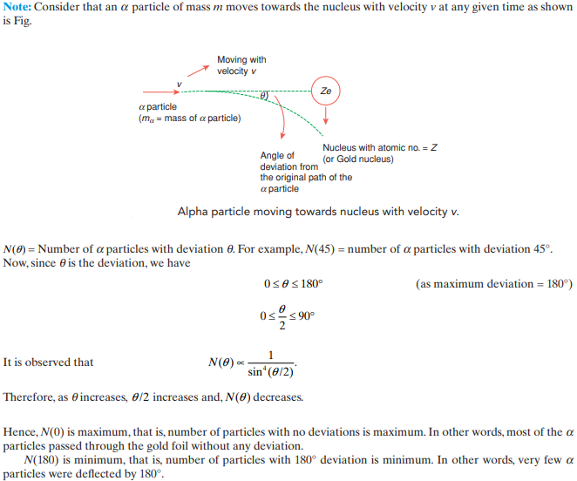3. This model was unable to explain the energies of electrons and their distribution around the nucleus.

**Atomic Number and Mass Number:**

In 1913, **Moseley** studied the frequencies of the X-rays given off when the electrons in the cathode ray tube strike the anode made with different elements. He found that wavelength of X-ray decreases in the regular way on moving from the lighter to heavier element. He formulated the relationship as Moseley's law and expressed it mathematically as:



Where a and b are constants and Z is the atomic number. He concluded that since the frequencies of the X-ray emitted depend on the charge on the nucleus; therefore, Z is a fundamental property of an atom and named it as **atomic number**. It was equal to the positive charge (charge on nucleus) of an atom.

**Atomic number (Z)** = number of protons in the nucleus of an atom

= number of electrons in a neutral atom

While the positive charge of the nucleus is due to protons, the mass of the nucleus, due to protons and neutrons. As discussed earlier protons and neutrons present in the

nucleus are collectively known as **nucleons.** The total number of nucleons is termed as mass number (A) of the atom.

**Mass number (A)** = number of protons (Z) + number of neutrons (n)

**Isobars and Isotopes**: The atoms which have same mass number but different atomic numbers are called **isobars**. For example, and.

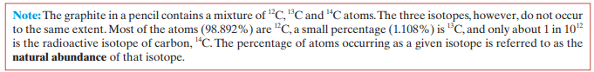The **isotopes** of an element have the same atomic number but different mass numbers. The difference in isotopes exists because of the difference in the number of neutrons. Carbon, for example, has three naturally occurring isotopes: 12C, 13C and 14C.

**Note:** The chemical properties are dependent on the number of electrons which in turn depends on the number of protons. The number of protons in the nucleus of an atom determines the identity of the atom. So, all isotopes show similar chemical properties. As a result, all atoms of an element must have the same number of protons. But they do not have to contain the same number of neutrons. Atoms or ions containing same number of electrons are called **isoelectronic species**. For example, F−, Na+, Mg2+, Al3+, Ne

**Isotones, Isodiaphers and Nuclear Isomers**: Two nuclei having the same number of neutrons or same value of (A−Z) are called **isotones** they differ in their atomic number and mass number but contain the same number of neutrons. For example, and are isotones.

Two nuclei with the same difference between number of neutrons and protons or having same value of (A−Z)−Z or (A−2Z) are called **isodiaphers**. For example, and are isodiaphers.

When two nuclei have the same A and Z but different characteristics, they are called nuclear isomers. For example, and are **nuclear isomers**.

**Developments leading to the Bohr’s Model of Atom:** Historically, results observed from the studies of interactions of radiations with matter have provided immense information regarding the structure of atoms and molecules**. Neils Bohr** utilised these results to improve upon the model proposed by Rutherford. Two developments played a major role in the formulation of Bohr’s model of atom.

These were:

(i) Dual character of the electromagnetic radiation which means that radiations possess both wave like and particle like properties, and

(ii) Experimental results regarding atomic spectra.

**NATURE OF WAVES :**

Consider the displacement (oscillation) of a particle by transfer of energy as shown in figure. Then the related terms are defned as:

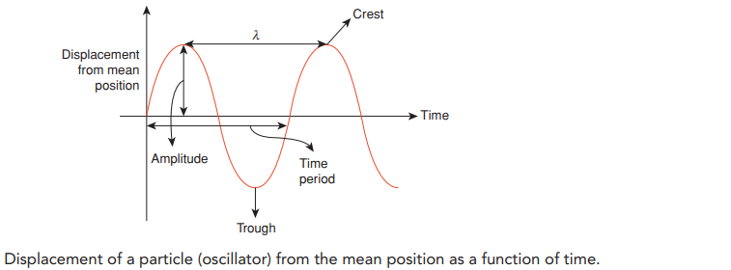

**Wave:** An oscillation accompanied by a transfer of energy that travels through space and mass.

**Wavelength:** Wavelength can be defined as the distance between two maxima of a wave. It is expressed in meters. It is denoted by λ.

**Frequency:** It is defined as the number of waves that pass a fixed point in unit time. It is expressed in s-1 or Hz. It is denoted by v.

**Wavenumber**: It is defined as the number of waves per unit distance. It is reciprocal of wavelength. It is denoted by.

**Time period**: The time taken for completion of one wave. It is expressed in s (second). It is denoted by T.

**Amplitude:** It is defined as the maximum displacement of a wave from its mean position.

**Wave Nature of Electromagnetic Radiation:**

A series of groundbreaking experiments showed that classical physics does not correctly describe energy transfer by electromagnetic radiation. In 1870, Max Planck (1858-1947), a German physicist, proposed that electromagnetic radiation can be viewed as a stream of tiny packets or **quanta** of energy that were later called **photons**. Scientists divide matter into two categories, particles and waves. Particles are easy to understand because they have a measurable mass and they occupy space. Waves on the other hand have no mass and yet they carry energy as they travel through space.

In the case of electromagnetic radiation, the disturbance can be a vibrating electric charge. When the charge oscillates, it produces a pulse in the electric field around it. As the electric field pulses, it creates a pulse in the magnetic field. The magnetic field pulse gives rise to yet another electric field pulse further away from the disturbance. The process continues, with a pulse in one field giving rise to a pulse in the other, and the resulting train of pulses in the electric and magnetic fields is called an electromagnetic wave. When an electromagnetic wave passes an object, the oscillating electric and magnetic fields may interact with it.

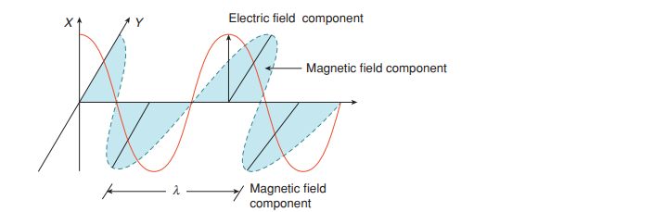

The energy associated with regions of the electromagnetic spectrum is related to wavelengths and frequency by the equation:

E=hν=

Where E = energy of the radiation in joules; h = Planck’s constant, 6.626 × 10−34 J s; ν = frequency of radiation in Hz and c = velocity of light, 2.998 × 108 m s−1 .

Although electromagnetic wave motion is complex in nature, we will consider here only a few simple properties.

(i) The oscillating electric and magnetic fields produced by oscillating charged particles are perpendicular to each other and both are perpendicular to the direction of propagation of the wave.

(ii) Unlike sound waves or waves produced in water, electromagnetic waves do not require medium and can move in vacuum.

(iii) It is now well established that there are many types of electromagnetic radiations, which differ from one another in wavelength (or frequency). These constitute what is called **electromagnetic spectrum**. Different regions of the spectrum are identified by different names.

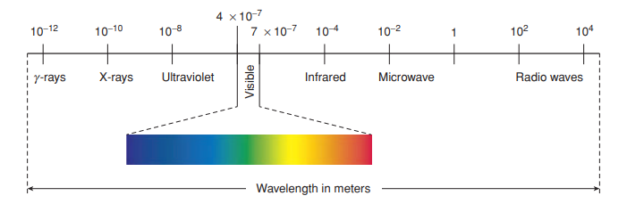

**PLANCK'S QUANTUM THEORY**

According to Planck's quantum theory, energy of each electromagnetic wave is limited to discrete value and cannot be varied arbitrarily. This proposal contradicts classical physics according to which each oscillator has a fixed mean value of energy KT.

According to Planck's theory, energy is emitted or absorbed in the form of small packets. Each packet is known as **quantum**. In case of the electromagnetic radiation being light, this quantum of energy is known as **photon**. If energy of one packet = E1, it was observed that

E1ν

(Frequency of electromagnetic wave)

E1 = hv

Where h is the Planck's constant (6.626 ×10-34 Js. If we have a photons with total energy E, then,

E = nhν =

Where n = 0, 1, 2, 3 .This is known as the quantization of energy.

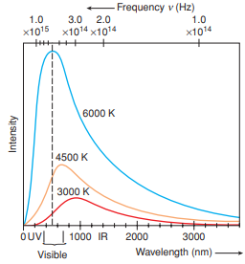**Blackbody Radiation**

It was observed by the physicists that when solids are heated, they emit radiation over a wide range of wavelengths. For example, when an iron rod is heated in the furnace, it progressively changes to a stronger red color, then becomes white and turns blue when heated to even higher temperature. In terms of frequency, it implies that on progressive heating, the frequency of energy emitted by the object rises from a lower to a higher value with increase in temperature. A body which can emit or absorb radiation of all frequencies is known as blackbody and the radiation emitted by it is known as blackbody radiation.

At a given temperature, the spectral emissive power, of light emit-ted by a blackbody depends on the wavelength emitted. At a given temperature, the intensity of radiation emitted increases with increase of wavelength, reaches a maximum value and then decreases with further increase in wavelength. Furthermore, Wein found out that if we increase the temperature of the blackbody, the wavelength corresponding to the most intense radiation decreases. Both these observations are illustrated graphically in Figure.

The first explanation for blackbody radiation was given by Max Planck. According to Planck's quantum theory, energy is not continuous but is discrete. The smallest quantity of this energy is called quantum. The energy can be given as E = hv. This means that energy occurs in "packets" called quanta, of magnitude h/2n, where h is Planck's constant and its value is 6.626 × 10-34  Js With this theory, Planck was able to explain the distribution of intensity of radiation emitted by a blackbody as a function of wavelength or frequency at a given temperature.

**Evidence for the quantized Electronic Energy Levels: Atomic spectra**

****A spectrum is formed when the light from an object that has been heated to a very high temperature (such as the filament in an electric light bulb) is split by a prism and displayed on a screen. A rainbow after a summer shower appears as a continuous spectrum that most people have seen. In this case, tiny water droplets in the air spread out the colors contained in sunlight. The spectrum of white light (visible light) is a **continuous spectrum** (ranging from 7.5 × 1014 Hz for violet to 4 × 1014 Hz for red) because it contains a continuous unbroken distribution of light of all colors. The red light with the longest wavelength deviates the least, while the violet light with the shortest wavelength deviates the most.

When electromagnetic radiation interacts with matter in form of atoms, molecules or ions, these absorb energy and are raised to higher energy level. When they return to the more stable ground state, the atoms and molecules emit energy in various specific regions of electromagnetic spectrum. The atoms of the given element always undergo the same specific energy changes; this is because electrons can have only certain definitive amounts of energy. Hence, the energy at electronic level is **quantized**.

**Emission and Absorption Spectra**

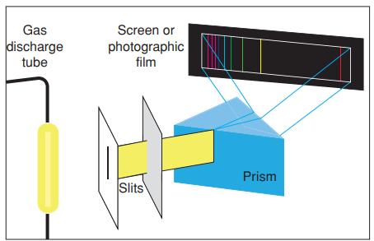The spectrum of radiation emitted by a substance that has adsorbed electromagnetic radiation is known as an **emission spectrum**. To obtain an emission spectrum, a sample is either heated in a flame or irradiated with a beam of light; the atoms/molecules/ions of the sample absorb the energy from the radiation and are raised to unstable excited state. They revert to the more stable lower energy state by losing the absorbed energy and emitting radiations of specific wavelengths which are recorded as the emission spectrum. When the radiation is passed through a sample, it absorbs certain wavelengths. When the continuous spectrum is observed, there are a few dark spaces which represent the radiation that is absorbed by the matter. This is called **absorption spectrum**.

**Spectroscopy** is a study of either the radiation absorbed or the radiation emitted. Atomic spectroscopy is an important technique for studying the energy and the arrangement of electrons in atoms. When a narrow beam of this light emitted by an element is passed through a prism, we do not see a continuous spectrum. Instead, only a few colors are observed, displayed as a series of individual lines. This series of lines is called the element's **atomic spectrum or emission spectrum**. The emission spectra of visible light are continuous, but that of gaseous atoms contain lines with dark spaces between them. This is called **line spectra or discontinuous spectrum**.

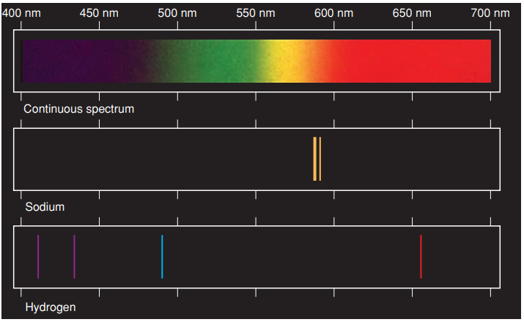Figure shows the visible portions of the atomic spectra of hydrogen spectrum has five lines in the visible region of the electromagnetic spectrum red, green, blue, violet1 and violet2. But **Balmer** could see only four lines and a continuum. In fact, each element has its own unique atomic spectrum that is as characteristic as a fingerprint, and can be used to identify the element.

**BOHR’S MODEL FOR HYDROGEN ATOM**

In 1913, working further on Rutherford’s model for atomic nucleus, Niels Bohr suggested that the atomic nucleus was surrounded by electrons moving in orbits like planets round the sun. He was awarded the Nobel Prize for Physics in 1922 for his work on the structure of the atom.

**Bohr's Postulates**

Bohr's model of atom is based on the following postulates:

1. The electron moves around the nucleus in orbits (arranged concentrically around the nucleus). These orbitals have a fixed radius and energy. An electron does not radiate energy if it stays in one orbit, and therefore does not slow down.

2. When an electron is moving in a circular orbit it experiences a centripetal acceleration of . Since an electron is experiencing an attractive force from the nucleus =

Therefore,

=

Number of revolutions of electron per second=

3. When an electron remains in its orbit or stationary state, the angular momentum is given by

where n = 1, 2, 3,…….. Thus an electron can move only in those orbits for which the angular momentum is an integral multiple of h/2π. Hence, only certain fixed orbits are permitted around the nucleus in an atom. It is applicable only for single electron species

The integral numbers n = 1, 2, 3 ,..., are the principal quantum numbers and correspond to permitted stationary states for electron in an atom..

4. The difference in energy observed when the frequency of radiation is absorbed or emitted is given by the Bohr frequency rule, as shown in the following figure.

ν = =

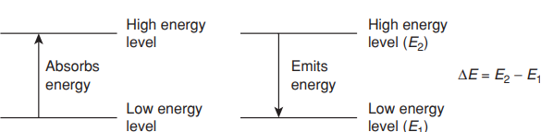

Bohr's model for hydrogen could successfully predict the radius of Bohr orbit, the velocity of electron in an orbit and the energy associated with an electron in each energy level. It could be extended to predict these parameters for hydrogen-like species.

**Radius of Bohr Orbits in Hydrogen**:

The radius of the stationary states is known as Bohr radius and the radius of stationary state in hydrogen atom can be calculated as follows.

ΔE = E2 - E1

For an electron to remain in its orbit, the electrostatic attraction between the electron and the nucleus which tends to pull the electron towards the nucleus must be equal to the centrifugal force which tends to throw the electron out of its orbit.

Centrifugal force =

If the charge on the electron is e, the number of charges on the nucleus Z, and the permittivity of a vacuum then,

Coulombic attractive force = =

Where constant k = = 8.988×109 Nm/C2.

So,



Hence,



According to Planck's quantum theory, energy is not continuous but is discrete. This means that energy occurs in "packets" called quanta. The angular momentum mvr of an electron in orbit must be equal to a whole number n multiple of h/2π.



Combining above equations, we get

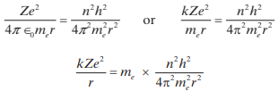

Hence,



For hydrogen the charge on the nucleus Z = 1 and if n = 1 this gives a value r = 12×0.0529 nm and for n = 2, r = 22×0.0529 nm. In general, rn = n2 × a0 where a0= 0.0529 nm. This gives a picture of the hydrogen atom where an electron moves in circular orbits of radius proportional 12, 22, 32 ,……… Thus, Bohr radius can be expressed as rn = n2a0 ,where

a = 52.9 pm. The Bohr radius of first stationary state is 52.9 pm and the electron is generally found in this orbit.

From the above equation, we have



where r0 =0.529 A0 .

Thus,



**Velocity of Electron**

The velocity of electron moving in the orbit is given by the expression

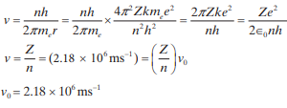

Thus v is independent of m.

**Energy of Electron in Hydrogen Atom:**

For hydrogen atom, the energy associated with an electron in the stationary state in which it is present can be obtained by using the value of Bohr radius and is calculated as follows.

The total energy of an electron in a one-electron system = Kinetic energy + Potential energy. The kinetic energy of the electron is



The potential energy of an electron at an infinite distance from the nucleus is taken to be zero. The potential energy of the electron at a distance r from the nucleus is the work done in moving the electron from infinity to the point which is at a distance r from the nucleus. We know that the coulombic attractive force is given by



Therefore, to find the work done by this variable force, we find the work done in moving the electron through an infinitesimally small distance (over which the force may be assumed to be constant) and integrating over the entire distance. The work done in moving through small distance dr is given by



The total work done in moving the electron from infinity to the point at a distance r from the nucleus is given by the integral



The total energy of the electron is kinetic energy + potential energy



From the above equations,we get



Thus



Substituting in the above equation, we get



Substituting the value of r we get



**Note**: We know that, Τ.Ε=Κ.Ε+PE. Where T.E. is total energy, K.E. is kinetic energy and P.E. is the potential energy.





If we assume K.E. be x, then, PE. = -2x

Also,Τ.Ε= Κ.Ε + P.E = x + (- 2x) = x - 2x =-X

Thus, if K.E. = x, then P.E. = 2x and T.E. = -x

For an atom of hydrogen, Z = 1, me = 9.11 × 10−31 kg, e = 1.6 × 10−19 C, ∈0 = 8.85 × 10−12 C2 N−1m−2,

h = 6.626 × 10−34 J s. Substituting these values), we get



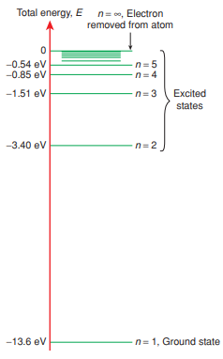therefore E m.

The energy of the electron in the stationary state n1 and n2 in an atom of hydrogen are given by



Thus, the energy of electron is given by the expression



where RH is the Rydberg constant for hydrogen and its value is 2.18 ×10 -18 J.

Energy for first orbit or the ground state is



Energy for the second orbit is



Note that a free electron corresponds to being present in orbit n = ∞ and is infinitely away from the nucleus, and thus, its energy is taken as zero. When the electron is present in any other stationary state (orbit) n, it is attracted to the nucleus and its energy is lowered. The energy of electron in orbit n is thus larger in absolute value than zero, but is denoted with a negative sign, since it is being lowered. The negative sign for the energy thus represents the relative stability of the state with reference to zero energy state n = ∞.

The line spectrum observed for hydrogen can be explained quantitatively using Bohr’s model. The various lines obtained in the spectrum can be related to transition between different energy states. When an electron undergoes a transition from initial state ni to final state nf, the energy change is given by



When the electron moves from the stationary state n2 to the stationary state n1, the energy it releases will be



Therefore, the frequency of the radiation emitted during the transition of the electron is



This is the equation given by J.J. Balmer while studying the hydrogen spectrum.



Therefore,

Now,

Where = , wave number, that is, the number of waves in 1 m.



where 1.09677 ×107 m-1 is the Rydberg's constant. For hydrogen, R=RH .



This means that the energy of the electron in an atom of hydrogen is given by.



The energy of the electron in any one-electron system is given by



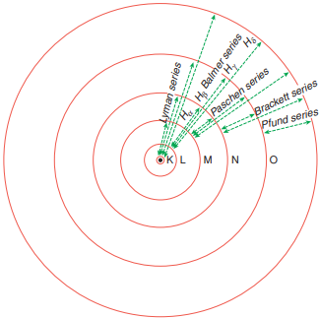The different series of spectral lines obtained in atomic spectra of hydrogen can be obtained by varying the values of ni and nf. Thus with nf = 1and ni = 2, 3, 4, etc., we obtain the **Lyman series** of lines in the UV region. With nf = 2 and ni = 3, 4, 5, etc., we get the **Balmer series** of lines in the visible spectrum. Similarly, nf = 3 and ni = 4, 5, 6, etc., gives the **Paschen series**, nf = 4 and ni = 5, 6, 7, etc., gives the **Brackett series**, and nf = 6 and ni = 7, 8, 9, etc., gives the **Pfund series**

The intensity of spectral lines depends upon the number of photons of the required frequency emitted and absorbed.

The various transitions which are possible between orbits of hydrogen are shown in the figure. The orbits are sometimes denoted by the letters K, L, M, N, … , counting outwards from the nucleus, and they are also numbered 1, 2, 3, 4, …. This number is called the **principal quantum number**, which is given the symbol n. It is therefore possible to define which circular orbit is under consideration by specifying the principal quantum number.

**Note**: When an electron moves from one orbit to another, it should give a single sharp line in the spectrum, corresponding precisely to the energy difference between the initial and final orbits. If the hydrogen spectrum is observed with a high resolution spectrometer, it is found that some of the lines reveal “fine structure”. This means that a line is really composed of several lines close together.

**Ionization Energy (Enthalpy)**

Ionization enthalpy is the energy required to remove the electron from the atom in gaseous state and convert it into an ion. In terms of Bohr’s theory it amounts to a transition of electron from ground state n = 1 to n = ∞ on absorption of energy equal to ionization enthalpy. It is thus possible to calculate the ionization enthalpy of hydrogen and hydrogen-like species using the formulas

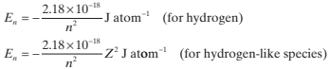

**Line Spectra of Hydrogen**

If a discharge is passed through a glass tube containing hydrogen gas (H₂) at a low pressure, some hydrogen atoms (H) are formed, which emit light (pink-violet) in the visible region. This light can be studied with a spectrometer, and is found to comprise a series of lines of different wavelengths. Four lines can be seen by eye, but many more are observed photographically in the ultraviolet region. The lines become increasingly close together as the wavelength decreases, until the continuum is reached.

**Note**: In spectroscopy, waves are generally described as wave number where = m−1. Wavelengths, in meters, are related to the frequency, n, in Hertz (cycles per second) by the equation , where c is the velocity of light (3 × 108 ms−1).

In 1885, Balmer showed that the wave number of any line in the visible spectrum of atomic hydrogen could be given by the simple empirical formula:



where RH is the Rydberg constant and n has the values 3, 4, 5, …; thus giving a series of lines. This is known as the Balmer formula. The series of lines given by this formula is called the Balmer series which appear only in the visible region of the electromagnetic spectrum. Rydberg, a Swedish physicist, showed that the lines can be given by the following formula:



where n1 = 1, 2, … and n2 = n1 + 1, n1 + 2, …. The value of Rydberg constant is 109677 cm−1 . Apart from Balmer series, several other series of lines may be observed in different regions of the spectrum

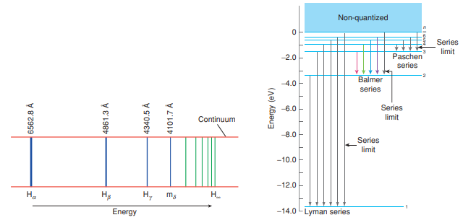

Spectral series found in atomic hydrogen

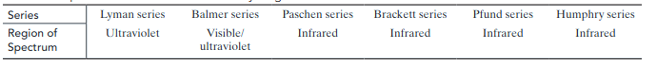

Similar equations were found to hold for the lines in the other series in the hydrogen spectrum.

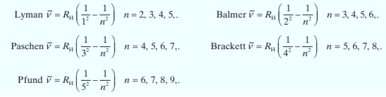

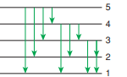**Total Number of Spectral Lines**

Consider the case in which we have a lot of atoms and we want to calculate the total number of spectral lines possible. From the given Figure, we have that the following transitions will be possible 51, 52, 53, 54, 41, 42, 43, 32, 31, 21, that is, 10 spectral lines.

If n1 and n2 are the two energy levels between which the transition is made, then maximum number of spectral lines between them is given by



where Δn = n2 - n1 For example, in the above case Δn = 5 - 1 = 4

Therefore, maximum number of spectral lines = = 10

**Limitations of Bohr's Model**

By calculating the energy changes that occur between energy levels, Bohr was able to account for the Rydberg equation and, therefore, for the atomic spectrum of hydrogen. However, the theory was not able to explain quantitatively the spectra of atoms with more than one electron, and all attempts to modify the theory to make it work met with failure. Some important deficiencies of Bohr's theory are listed as follows:

1. It accounts for the line spectra of only one-electron systems such as H. He+ and Li2+.

2. Each of the four lines of the hydrogen spectrum observed by Balmer, when viewed through a high-resolution spectrometer, is found to be made up of six different lines. Bohr's theory does not explain this.

3. It assumes that electrons revolved round the nucleus in circular orbits. Sommerfeld explained the splitting of the spectral lines of hydrogen by assuming that some electron orbits were elliptical.

4. It does not explain the splitting of spectral lines by magnetic fields (Zeeman effect) and by electric fields (Stark effect).

5. According to this theory, the total energy of an electron is the sum of its potential and kinetic energies. It is now known that electrons spin on their own axis. The energy of the spin is not taken into account in Bohr's theory.

6. Bohr assumes that the angular momentum of an electron in an atom of hydrogen is an integral multiple of h/2π but his theory does not explain the reason for this assumption.

7. Using this theory, we are able to find the position of an electron and its velocity in an atom of hydrogen. But according to **Heisenberg's uncertainty principle**, it is impossible to know both the position and momentum of a fast-moving electron accurately at the same time.

8. It does not take into account the wave nature of the electron.

**Bohr-Sommerfeld Model**

Bohr's model was extended by Sommerfeld to study the line spectrum of one-electron systems. Using a high resolving power spectroscope, it was found that a line is a collection of more than one fine line of similar wavelength, resulting in a fine spectrum. Some of the important features of the model were

1. It described the orbits containing electrons revolving around the nucleus to be elliptical instead of being circular with definite energy levels.

2. It described the atom using two quantum numbers instead of one, that is, n and k where k is called azimuthal quantum number. It is equal to 1, 2,... n but k≠ 0. Thus, when a transition of electron takes place from a higher level to a lower one, it would be differ from that proposed by Bohr because there could be more than one values of k. Thus, the reason from fine spectrum could be explained.

3. It stated that the angular momentum of electron in closed elliptical paths is quantized, that is Lk = k(h/2π)

4. The relation between n and k gives an estimate of possible number of subshells contained in a shell. The ratio of n to k is numerically equal to the ratio of the length of major axis to that of minor axis. On increasing k, the path becomes more eccentric, whereas if n / k = 1 then the path is circular.

In spite of the enhanced features, there were certain limitations to Sommerfeld theory. These are as follows:

1. It was restricted to one-electron systems only, and could not explain the spectrum and electron-electron repulsions of polyelectron systems.

2. It was unable to explain the **de Broglie equation**, even though it indicated that momentum in closed elliptical paths is quantized.

**PHOTOELECTRIC EFFECT**

Photoelectric effect is the phenomenon in which electrons are emitted from a metal surface when radiation of sufficient energy falls on it. Metals such as sodium, lithium and potassium show photoelectric effect with visible light, whereas metals like zinc, magnesium, and cadmium show photoelectric effect with ultraviolet light.

The phenomenon of photoelectric emission was discovered in 1887 by Heinrich Hertz (1857-1894) during his electromagnetic wave experiment. Hertz found that high voltage sparks across a detector loop were enhanced when an emitter plate was illuminated by ultraviolet light from an arc lamp. This was explained as follows: When the emitter plate was illuminated by ultraviolet light, some electrons near the surface of the metallic emitter plate absorb energy from the ultraviolet rays. This enables them to overcome the force of attraction due to positive ions in the material of the emitter and finally escape from the emitter surface into the surrounding space, hence enhancing the high voltage sparks across the detector. Because the electrons are ejected with the aid of light, they are called photoelectrons.

In another experiment, a negatively charged zinc plate was connected to an electroscope. It was found that the zinc plate lost its charge when it was illuminated by ultraviolet light. The uncharged zinc plate became positively charged when it was irradiated by ultraviolet light. It was concluded that the negatively charged particles were emitted from the zinc plate under the action of ultraviolet light. These observations were formulated as the laws of

photoelectric effect.

1. The electrons are ejected from the surface as soon as the surface was irradiated by the beam of light.

2. The number of electrons emitted from the surface is proportional to the intensity of the incident beam.

3. Electrons could be made to leave a metal's surface only if the frequency of the incident radiation was above some minimum value, which was named the threshold frequency (ν0). This threshold frequency differs for different metals, depending on how tightly the metal atom holds onto electrons.

4. Above the threshold frequency (ν> ν0), the ejected electrons come out with certain kinetic energy. The kinetic energy of the emitted electron increases with increasing frequency of the light. In his photoelectric theory, Einstein proposed that light of frequency v could be regarded as a collection of discrete packets of energy (photons), each packet containing an amount of energy E given by E=hv, where h is Planck's constant.

Einstein explained the photoelectric effect thus: An electron absorbs a quantum of energy (hv) from light and if the energy absorbed is greater than the minimum energy (hν0) required by an electron to escape from the metal surface (known as work function W0), then the electron is ejected from the metal surface with some kinetic energy. Einstein summed up the results of the photoelectric experiments in the equation:

**hv = + hν0 + K.E = hν0 + mv2**

where, K.E. is the kinetic energy of the electron that is emitted, hv is the energy of the photon of frequency v and hν0 is the minimum energy needed to eject the electron from the metal's surface.

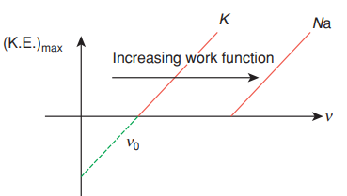

**Detailed Analysis of Photoelectric Effect**

1. **Stopping potential**(Vs) : It is defined as the potential necessary to stop the electron having the maximum K.E. which has been emitted in photoelectric effect.

eVs =(K.E.)max

2. **Accelerating Potential Voltage** (V): If accelerating voltage is provided to an emitted electron, then it will further increase the K.E. of the emitted electron. For example, if accelerating voltage V1 is applied, then the emitted electron will have minimum kinetic energy eV1, and maximum kinetic energy =(K.E.) max + eV1 .

**Note**: In photoelectric effect, the ejected photoelectrons can have any K.E. from 0 to

(K.E.) max

3. The (K.E.)max of the ejected photoelectron is directly proportional to frequency v of the radiation. It is independent of the intensity of the radiation.

hv=hv0 +(K.E.) max

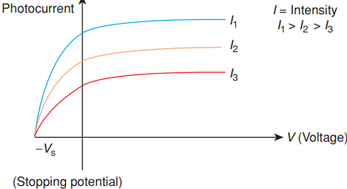

4. The magnitude of photocurrent is directly proportional to intensity of radiation (assuming same metal on which different intensities of photons are radiated). As each photon can eject maximum of one photoelectron, as intensity increases, the number of photons increases and thus, number of photoelectrons ejected increases. As a result, photocurrent increases.

**DUAL NATURE OF MATTER:** The planetary theory of atomic structure put forward by Rutherford and Bohr describes the atom as a central nucleus surrounded by electrons in certain orbits. The electron is thus considered as a particle. In the 1920s, it was shown that moving particles such as electrons behaved in some ways as waves. The two important developments in that regard were dual behavior of matter and Heisenberg uncertainty principle.

de Broglie Equation When bound inside an atom, electrons behave not like solid particles, but instead like waves. This idea was proposed in 1924 by a young French graduate student,

Louis de Broglie. The matter waves, like the light waves are characterized by their wavelengths and their frequencies. For matter waves E = mc2 and for light waves E =

Therefore, λ =

The general form of equation is

λ = =

Where h is Planck’s constant, m is the particle’s mass, v is its velocity and p is the momentum.

When kinetic energy is given,



These relations allow us to connect a wave property, wavelength, with particle properties, mass and velocity. We may describe the electron either as a particle or a wave, and the de Broglie relationship provides a link between the two descriptions. Electrons are no longer assumed to be moving in circular stationary orbits as proposed by Bohr. According to de Broglie, electrons move in the form of waves. The circumference of the nth orbit in a one-electron system is equal to n (the de Broglie wavelength of the electron). Just as in case of electromagnetic radiation, some properties of electrons can be explained on the basis of wave nature and the others on the basis of particle nature. The distinguishing features of electromagnetic waves and matter waves are shown in the following Table.

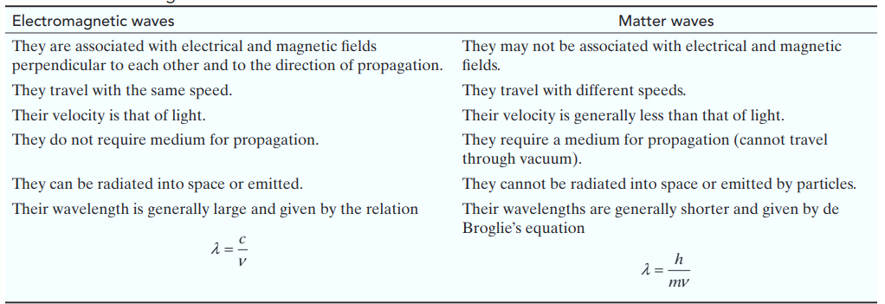

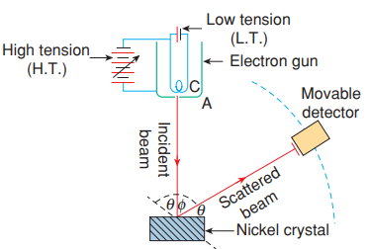

**Experimental Evidence for Wave Nature of Electrons**: The first experimental proof for wave nature of electrons demonstrated by American physicists **Davisson and Germer**. The principle involved was that since the wavelength of an electron is of the order of spacing of atoms of a crystal, a beam of electrons shows diffraction effects when incident on a crystal. In the experimental set up, electrons from a hot tungsten cathode are accelerated by potential difference V between the cathode (C) and the anode (A). A narrow hole in the anode renders the electrons into a fine beam and allows it to fall on a nickel crystal. The electrons are scattered by the atoms in the crystal in all direction and pattern of the scattered beam is captured by a detector. Davisson and Germer made the following modifications in de Broglie’s equation:

If the charged particle (electron) is accelerated with a potential of V, then kinetic energy is given by:



Then from de Broglie's relation, we have

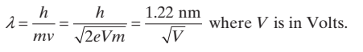

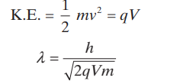For any charged particle of charge q,

**HEISENBERG’S UNCERTAINTY PRINCIPLE**: Calculations on the Bohr model of an atom require precise information about the position of an electron and its velocity. According to Heisenberg’s uncertainty principle, it is difficult to measure both quantities accurately at the same time. An electron is too small to see and may only be observed if perturbed. For example, we could hit the electron with another particle such as a photon or an electron, or we could apply an electric or magnetic force to the electron. This will inevitably change the position of the electron, or its velocity and direction. Heisenberg stated that the more precisely we can define the position of an electron, the less certainly we are able to define its velocity, and vice versa. If Δx is the uncertainty in defining the position and Δpx (or Δvx) the uncertainty in the momentum (or velocity), the uncertainty principle may be expressed mathematically as:

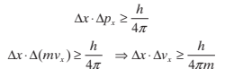

where h = Planck’s constant = 6.626 × 10−34 Js

**Note**: When visible light falls on a macroscopic object, the photons of the incident light are scattered by the object and the reflected light enters our eye. We are thus able to see the object, determine its position and estimate its velocity. The position and velocity of the macroscopic object does not undergo any distinct change on impact of radiation (photon of energy). In contrast, microscopic objects, undergoes considerable change in its path and velocity (or momentum) on being struck by a photon of radiation. Thus, it is not possible to simultaneously determine the position and velocity of microscopic object like an electron.

**Significance of Uncertainty Principle**

1. The uncertainty principle limits the precision with which two complementary properties position and momentum of a subatomic particle can be measured. The principle has been expanded to include energy and position, angular position and angular momentum, and other pairs of variables that cannot be simultaneously known.

2. It also leads to the conclusion that the properties of a subatomic particle observed are not independent of the observer and can take a range of values.

3. Using Bohr's atomic theory, we could calculate the radius of a one-electron system (such as H, He+ and Li2+) and the velocity of the electron in orbit. But according to Heisenberg's uncertainty principle, it is not possible to know the position or the velocity of an electron with any degree of accuracy. Therefore, we can only describe the probability of finding an electron in a given volume rather than its exact position. In diagrams drawn to show the position of electrons, their position at different instances of time is marked as dots. The radius of an atom of hydrogen is arbitrarily taken to be the radius of the sphere within which the electron is found 90% of the time.

4. For objects of large mass, the uncertainty in the position (Δx) and the uncertainty in the velocity (Δv) are insignificant because the value of h/4n is very small and is equal to

5.273 × 10-35 Js and its mass is very large compared to the value of h/4π.

5. Heisenberg's principle becomes significant in case of microscopic objects like an electron. The mass of an electron is 9.11×10-31 kg, then according to Heisenberg's principle



Substituting values, we get



If we try to find the exact location of the electron, say to an uncertainty of 10-9 m, then the uncertainty in its velocity will be of the order of



This shows that it is difficult to justify the classical picture of atom based on Bohr’s theory that gives exact position and velocity of the electron in a Bohr orbit.

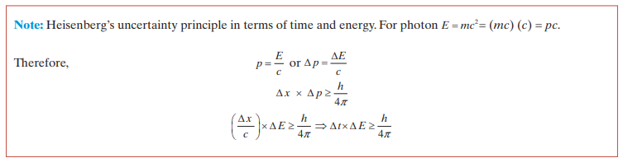

**NUMBER OF WAVES MADE BY THE ELECTRON**

Let the number of waves made be n1, then



Also

And



Combining the above three equations we can write



Therefore, **n = n1**

Thus, the number of waves made by an electron is equal to its principal quantum number.

**QUANTUM MECHANICAL MODEL OF ATOM**

Quantum mechanical theory of atomic structure was proposed to overcome the theoretical limitations in predicting the exact position of an electron at a particular instant. This theory of atomic structure is based on the wave particle duality of matter. It is insignificant for macroscopic objects because when applied to such objects, it yields the same results as those obtained with principles of classical physics.

In quantum mechanics, the concept of an electron following a definite orbit, where its position and velocity are known exactly, is replaced by the probability of finding an electron in a particular position, or in a particular volume of space. Postulates of quantum mechanics were developed independently by Heisenberg and Schrödinger. However, the fundamental equation of wave mechanics is the Schrödinger wave equation which provides a satisfactory description of an atom in these terms of duality of wave and particle.

For a system, such as an atom, whose energy does not change with time, the Schrödinger equation is given by

**Ψ = EΨ**

Here is a mathematical operator called Hamiltonian which is constructed based on the total energy of the system. Schrödinger took into consideration all the energies associated with the system, that is, the kinetic energy of all subatomic particles and potential energy of attraction between electrons and nuclei and that of repulsion among nuclei and electrons. Solutions to the wave equation are called wave functions and given by the symbol y. The solution gives the probability of finding an electron at a point in space whose coordinates are x, y and z is **Ψ**2(x, y, z) and the energy associated with it.

**Hydrogen Atom and the Schrödinger Equation**

The solution to the Schrödinger's wave equation for hydrogen atom gives the possible energy level that the electron may occupy and the corresponding wave function.



Acceptable solutions to the wave equation, that is, solutions which are physically possible, must have certain properties:

1. must be continuous.

2. must be finite.

3. must be single valued.

4. The probability of finding an electron at a point x, y, z over all space = = 1

Several wave functions called ,, ,..., will satisfy these conditions to the wave equation, and each of these has a corresponding energy levels E1, E2, E3 ,..., which an electron can occupy which are quantized. Each of these wave functions,, ,..., called an orbital, by analogy with the orbits in the Bohr theory. In a hydrogen atom, the single electron normally occupies the lowest of the energy levels E1This is called the ground state. The corresponding wave function describes the orbital, that is, the region in space where there is a high probability of finding the electron. For a one-electron system such as hydrogen, the probability of finding an electron at a point within the atom is 2.

**Important Features of the Quantum Mechanical Model of Atom**

Quantum mechanical model of atom is the picture of the structure of the atom, which emerges from the application of the Schrödinger equation to atoms. The following are the important features of the quantum-mechanical model of atom:

1. The energy of electrons in atoms is quantized (i.e., can only have certain specific values), for example when electrons are bound to the nucleus in atoms.

2. The existence of quantised electronic energy levels is a direct result of the wave like properties of electrons and are allowed solutions of Schrödinger wave equation.

3. Both the exact position and exact velocity of an electron in an atom cannot be determined simultaneously (Heisenberg uncertainty principle). The path of an electron in an atom therefore, can never be determined or known accurately. That is why, as you shall see later on, one talks of only probability of finding the electron at different points in an atom.

4. An atomic orbital is the wave function ψ for an electron in an atom. Whenever an electron is described by a wave function, we say that the electron occupies that orbital. Since many such wave functions are possible for an electron, there are many atomic orbitals in an atom. These “one electron orbital wave functions” or orbitals form the basis of the electronic structure of atoms. In each orbital, the electron has a definite energy. An orbital cannot contain more than two electrons. In a multi-electron atom, the electrons are filled in various orbitals in the order of increasing energy. For each electron of a multi-electron atom, there shall, therefore, be an orbital wave function characteristic of the orbital it occupies. All the information about the electron in an atom is stored in its orbital wave function ψ and quantum mechanics makes it possible to extract this information out of ψ.

5. The probability of finding an electron at a point within an atom is proportional to the square of the orbital wave function i.e., |ψ|2 at that point. |ψ|2 is known as probability density and is always positive. From the value of |ψ|2 at different points within an atom, it is possible to predict the region around the nucleus where electron will most probably be found.

**Orbitals and Quantum Numbers**

A large number of orbitals are possible in an atom. Qualitatively these orbitals can be distinguished by their size, shape and orientation. An orbital of smaller size means there is more chance of finding the electron near the nucleus. Similarly shape and orientation mean that there is more probability of finding the electron along certain directions than along others. Atomic orbitals are precisely distinguished by what are known as quantum numbers. Each orbital is designated by three quantum numbers labelled as n, l and ml.

**The principal quantum number ‘n’** is a positive integer with value of n = 1, 2, 3.......

The principal quantum number determines the **size** and to large extent the **energy** of the orbital. For hydrogen atom and hydrogen like species (He+, Li2+, .... etc.) energy and size of the orbital depends only on ‘n’.

The principal quantum number also identifies the **shell**. With the increase in the value of ‘n’, the number of allowed orbital increases and are given by ‘n2’ All the orbitals of a given value of ‘n’ constitute a single shell of atom and are represented by the following letters

n = 1 2 3 4 ............

Shell = K, L, M, N ............

Size of orbital increases with increase of principal quantum number ‘n’. In other words the electron will be located away from the nucleus. Since energy is required in shifting away the negatively charged electron from the positively charged nucleus, the energy of the orbital will increase with increase of n.

Angular momentum of an electron in any orbit, **mvr =**

**Azimuthal quantum number. ‘l’** is also known as orbital angular momentum or subsidiary quantum number. It defines the three-dimensional shape of the orbital. For a given value of n, l can have n values ranging from 0 to n – 1, that is, for a given value of n, the possible values of l are:

l = 0, 1, 2,.......... (n–1)

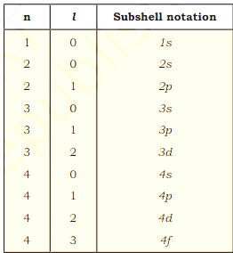For example, when n = 1, value of l is only 0. For n = 2, the possible value of l can be 0 and 1. For n = 3, the possible l values are 0, 1 and 2.

Each shell consists of one or more sub-shells or sub-levels. The number of sub-shells in a principal shell is equal to the value of n. For example in the first shell (n = 1), there is only one sub-shell which corresponds to l = 0. There are two sub-shells (l = 0, 1) in the second shell (n = 2), three (l = 0, 1, 2) in third shell (n = 3) and so on. Each sub-shell is assigned an azimuthal quantum number (l). Sub-shells corresponding to different values of l are represented by the following symbols.

Value for l: 0 1 2 3 4 5............

Notation for s p d f g h ............ sub-shell

Table shows the permissible values of ‘l ’ for a given principal quantum number and the corresponding sub-shell notation.

Magnitude of angular momentum of an electron in orbital, **mvr =**

**Magnetic orbital quantum number(ml**). It gives information about the spatial orientation of the orbital with respect to standard set of co-ordinate axis. For any sub-shell (defined by 'l' value) (2l + 1) values of ml are possible and these values are given by:

ml= -l, -(l-1), -(l-2) ……... 0,1... (l-2), (l-1), l

Thus for l=0, the only permitted value of ml = 0 [ 2×0 + 1 = 1 , one s orbital].

For I = 1, ml= -1, 0 and +1 [2×1 + 1 = 3 , three p orbitals].

For l=2, ml = - 2, - 1, 0, 1 and +2, [2×2 + 1 = 5 , five d orbitals].

For l=3, ml = -3,- 2, - 1, 0, 1,+2,+3 [2×3 + 1 = 7 , seven f orbitals].

It should be noted values of ml are derived from I and that the value of l are derived from n.

Each orbital in an atom, therefore, is defined by a set of values for n, l and ml . An orbital described by the quantum numbers n = 2, l = 1, ml = 0 is an orbital in the p subshell of the second shell. The following chart gives the relation between the subshell and the number of orbitals associated with it.

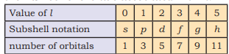

**Electron spin ‘s’** : The three quantum numbers labelling an atomic orbital can be used equally well to define its energy, shape and orientation. But all these quantum numbers are not enough to explain the line spectra observed in the case of multi-electron atoms, that is, some of the lines actually occur in doublets (two lines closely spaced), triplets (three lines, closely spaced) etc. This suggests the presence of a few more energy levels than predicted by the three quantum numbers.

In 1925, **George Uhlenbeck** and **Samuel Goudsmit** proposed the presence of the fourth quantum number known as the electron spin quantum number (ms). An electron spins around its own axis, much in a similar way as earth spins around its own axis while revolving around the sun. In other words, an electron has, besides charge and mass, intrinsic spin angular quantum number. Spin angular momentum of the electron — a vector quantity, can have two orientations relative to the chosen axis. These two orientations are distinguished by the spin quantum numbers ms which can take the values of +½ or –½. These are called the two **spin states** of the electron and are normally represented by two arrows, ↑ (spin up) and ↓ (spin down). Two electrons that have different ms values (one +½ and the other –½) are said to have opposite spins. An orbital cannot hold more than two electrons and these two electrons should have opposite spins.

To sum up, the four quantum numbers provide the following information:

i) **n** defines the shell, determines the **size** of the orbital and also to a large extent the energy of the orbital.

ii) There are n subshells in the nth shell. **l** identifies the subshell and determines the **shape** of the orbital. There are (2l+1) orbitals of each type in a subshell, that is, one s orbital (l = 0), three p orbitals (l = 1) and five d orbitals (l = 2) per subshell. To some extent l also determines the energy of the orbital in a multi-electron atom.

iii) **ml** designates the **orientation** of the orbital. For a given value of l, ml has (2l+1) values, the same as the number of orbitals per subshell. It means that the number of orbitals is equal to the number of ways in which they are oriented.

iv) **ms** refers to orientation of the **spin** of the electron.

**RADIAL AND ANGULAR WAVE FUNCTIONS**

The Schrödinger equation can be solved completely for the hydrogen atom, and for related ions which have only one electron such as He+ and Li2+. For other atoms only approximate solutions can be obtained. For most calculations, it is simpler to solve the wave equation if the Cartesian coordinates x, y and z are converted into polar coordinates **r**, and ϕ.The coordinates of the point A measured from the origin are x, y, and z in Cartesian coordinates, and **r**, and ϕ in polar coordinates. It can be seen from the figure that the two sets of coordinates are related by the following expressions:

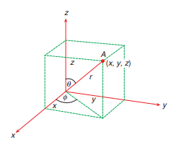

The Schrödinger equation is usually written:



Where







The solution of this is of the form



where R(r) is a function that depends on the distance from the nucleus, which in turn depends on the quantum numbers n and l. is a function of , which depends on the quantum numbers / and m. Φ(φ) is a function of φ, which depends only on the quantum number m. Above equation may be rewritten as:



This splits the wave function into two parts which can be solved separately:

1. R(r) the radial function, which depends on the quantum numbers n and l.

2. Aml the total angular wave function, which depends on the quantum numbers m and I.

**Radial Distribution Curve**

Since we are only plotting the radial part of the curve, therefore







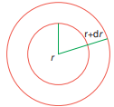

The small segment of volume dV is given by

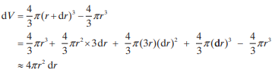

Thus,



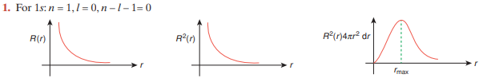

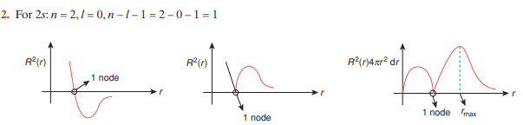

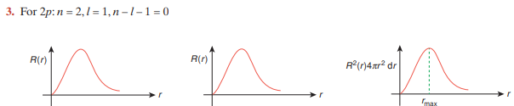

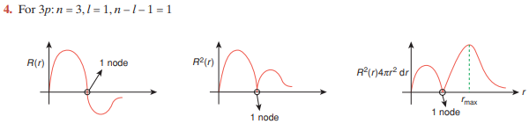

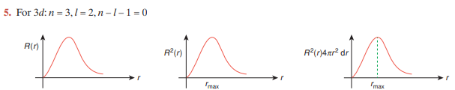

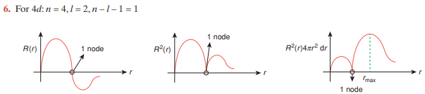

**Plot of Angular Wave Function**

The angular wave function A depends only on the direction, and is independent of the distance from the nucleus (r). Thus, A2 is the probability of finding an electron at a given direction ϕ at any distance from the nucleus to infinity. The angular functions A are plotted as polar. It must be emphasized that these polar diagrams do not represent the total wave function, but only the angular part of the wave function.

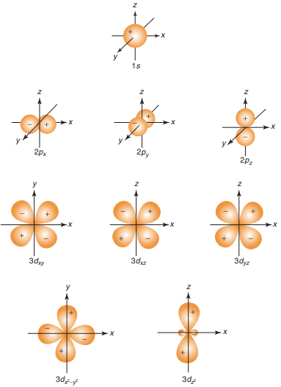

**Shapes of Atomic Orbitals**

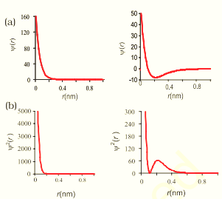The orbital wave function or for an electron in an atom has no physical meaning. It is simply a mathematical function of the coordinates of the electron. However, for different orbitals the plots of corresponding wave functions as a function of r (the distance from the nucleus) are different. Following figure gives such plots for 1s ( n = 1 , l=0) and 2s ( n = 2 , l=0) orbitals.

According to the German physicist, Max Born, the square of the wave function (i.e., ψ2) at a point gives the probability density of the electron at that point. The variation of ψ2 as a function of r for 1s and 2s orbitals is given in the figure. Here again, you may note that the curves for 1s and 2s orbitals are different [(a) and (b) respectively in the figure].

It may be noted that for 1s orbital the probability density is maximum at the nucleus and it decreases sharply as we move away from it. On the other hand, for 2s orbital the probability density first decreases sharply to zero and again starts increasing. After reaching a small maxima it decreases again and approaches zero as the value of r increases further. The region where this probability density function reduces to zero is called nodal surfaces or simply **nodes**. In general, it has been found that ns-orbital has **(n – 1) nodes**, that is, number of nodes increases with increase of principal quantum number n. In other words, number of nodes for 2s orbital is one, two for 3s and so on.

These probability density variation can be visualised in terms of charge cloud diagrams. In these diagrams, the density of the dots in a region represents electron probability density in that region.

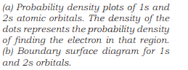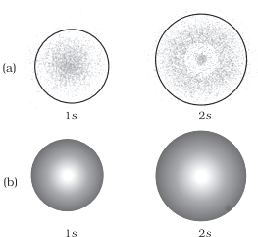**Boundary surface diagrams** of constant probability density for different orbitals give a fairly good representation of the shapes of the orbitals. In this representation, a boundary surface or contour surface is drawn in space for an orbital on which the value of probability density |ψ|2 is constant. In principle many such boundary surfaces may be possible. However, for a given orbital, only that boundary surface diagram of constant probability density is taken to be good representation of the shape of the orbital which encloses a region or volume in which the probability of finding the electron is very high, say, 90%. The boundary surface diagram for 1s and 2s orbitals are given in the figure. One may ask a question : Why do we not draw a boundary surface diagram, which bounds a region in which the probability of finding the electron is, 100 %? The answer to this question is that the probability density |ψ|2 has always some value, howsoever small it may be, at any finite distance from the nucleus. It is therefore, not possible to draw a boundary surface diagram of a rigid size in which the probability of finding the electron is 100%. Boundary surface diagram for a s orbital is actually a sphere centred on the nucleus. In two dimensions, this sphere looks like a circle. It encloses a region in which probability of finding the electron

is about 90%.

Thus, we see that 1s and 2s orbitals are spherical in shape. In reality all the s-orbitals are spherically symmetric, that is, the probability of finding the electron at a given distance is equal in all the directions. It is also observed that the size of the s orbital increases with increase in n, that is,

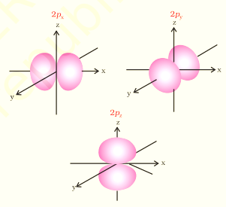4s > 3s > 2s > 1s and the electron is located further away from the nucleus as the principal quantum number increases.

Boundary surface diagrams for three **2p orbitals (l = 1)** are shown in the adjacent figure. In these diagrams, the nucleus is at the origin. Here, unlike s-orbitals, the boundary surface diagrams are not spherical. Instead each p orbital consists of two sections called lobes that are on either side of the plane that passes through the nucleus. The probability density function is zero on the plane where the two lobes touch each other. The size, shape and energy of the three orbitals are identical. They differ however, in the way the lobes are oriented. Since the lobes may be considered to lie along the x, y or z axis, they are given the designations 2px , 2py, and 2pz . It should be understood, however, that there is no simple relation between the values of ml (–1, 0 and +1) and the x, y and z directions. For our purpose, it is sufficient to remember that, because there are three possible values of ml , there are, therefore, three p orbitals whose axes are mutually perpendicular. Like s orbitals, p orbitals increase in size and energy with increase in the principal quantum number and hence the order of the energy and size of various p orbitals is 4p > 3p > 2p. Further, like s orbitals, the probability density functions for p-orbital also pass through value zero, besides at zero and infinite distance, as the distance from the nucleus increases. The number of nodes are given by the n –2, that is number of radial node is 1 for 3p orbital, two for 4p orbital and so on.

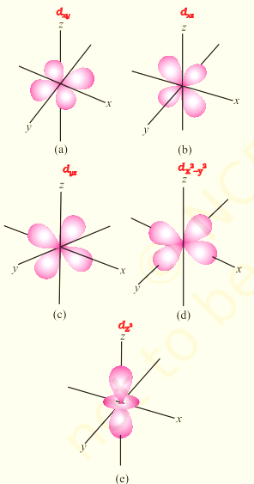

For **l = 2**, the orbital is known as **d-orbital** and the minimum value of principal quantum number (n) has to be 3. as the value of l cannot be greater than n–1. There are five ml values (–2, –1, 0, +1 and +2) for l = 2 and thus there are five d orbitals. The boundary surface diagram of d orbitals are shown in the figure.

The five d-orbitals are designated as dxy, dyz, dxz, dx2–y2 and dz2. The shapes of the first four d-orbitals are similar to each other, where as that of the fifth one, dz2, is different from others, but all five 3d orbitals are equivalent in energy. The d orbitals for which n is greater than 3 (4d, 5d...) also have shapes similar to 3d orbital, but differ in energy and size.

Besides the radial nodes (i.e., probability density function is zero), the probability density functions for the np and nd orbitals are zero at the plane (s), passing through the nucleus (origin). For example, in case of pz orbital, xy-plane is a nodal plane, in case of dxy orbital, there are two nodal planes passing through the origin and bisecting the xy plane containing z-axis.

These are called **angular nodes** and number of angular nodes are given by ‘l’, i.e., one angular node for p orbitals, two angular nodes for ‘d’ orbitals and so on.

* **The total number of nodes = (n–1)**,

**i.e., sum of l angular nodes and (n – l – 1) radial nodes**.

**Energies of Orbitals :**

In case of hydrogen, the energy of electron is determined only by the **principal quantum number**. The energy of all the orbitals in a given shell is the same, irrespective of the shape of the orbital. Thus, the order of energy levels is:

1s < 2s = 2p < 3s = 3p = 3d < 4s = 4p = 4d = 4f

The orbitals having the same energy are known as **degenerate orbitals**. The electron in hydrogen atom in its most stable state resides in the 1s orbital and this state is referred to as the ground state and the electron is most strongly held by the nucleus in this state. When the electron is raised to higher energy states, such as 2s, 2p, etc., it is said to be in the **excited state.**

In case of **multi-electron** atoms, the energy of an electron is determined by both the principal quantum number and the azimuthal quantum number, that is, it depends on both the shell as well as the subshell. The main reason for having different energies of the subshells is the mutual repulsion among the electrons in multi-electron atoms. The only electrical interaction present in hydrogen atom is the attraction between the negatively charged electron and the positively charged nucleus. For a given principal quantum number, s, p, d and f orbitals will have different energies. The relative energies of electron in an atom containing two or more electrons is shown in the following 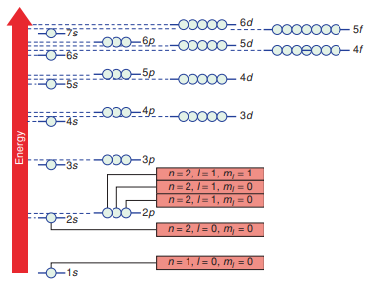figure.



The important observations from the energy level diagram are:

1. All the orbitals of a given subshell have the same energy.

2. In going upwards on the energy scale, the spacing between successive shells decreases as the number of subshells increases. This leads to some overlapping of shells having different values of n. For instance, the 4s subshell is lower in energy than the 3d subshell, 5s is lower than 4d, and 6s is lower than 5d. In addition, the 4f subshell is below the 5d subshell and 5f is below 6d.

**Filling of Orbitals in Atom**

The filling of electrons into the orbitals of different atoms takes place according to the aufbau principle which is based on the Pauli’s exclusion principle, the Hund’s rule of maximum multiplicity and the relative energies of the orbitals.

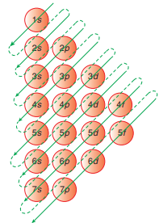**Aufbau Principle**:

In the case of atoms, electrons occupy the available orbitals in the subshells of lowest energy. This is known as the Aufbau principle (from the German for "building up"). The assignment of all the electrons in an atom into specific shells and sub-shells is known as the element's electron configuration.

It is important to know the sequence in which the energy levels are filled. Adjacent figure is a useful aid, which shows the order of filling of energy levels as:

1s, 2s, 2p, 3s, 3p, 4s, 3d, 4p, 5s, 4d, 5p, 6s, 4f, 5d, 6p, 7s, etc.

**The (n+1) rule**:

1. Higher the value of (n + 1) for a given orbital, greater is it's energy.

For example, 4s (n + l = 4 + 0 = 4) is has higher energy than

3s (n + l = 3 + 0 = 3)

2. If (n+1) value for two orbitals are same, then the orbital with higher value of n will have higher energy. For example 4s(n + l = 4 + 0 = 4) and 3p (n+1= 3+1=4) have same (n + 1) values, therefore 4s will have higher energy than 3p orbital due to higher value of n.

**Hund’s Rule of Maximum Multiplicity**

Hund’s rule states that where orbitals are available in degenerate sets, maximum multiplicity is preserved; that is, electrons are not paired until each orbital in a degenerate set has been half- filled. This is an empirical rule that determines the lowest energy arrangement of electrons in a subshell. It implies that pairing of electrons in orbitals of p, d and f subshells does not take place till each orbital belonging to that subshell has got one electron each.

Since there are three p, five d and seven f orbitals, therefore, the pairing of electrons will start in the p, d and f orbitals with the entry of 4th, 6th and 8th electron, respectively. It has been observed that half- filled and fully filled degenerate set of orbitals acquire extra stability due to their symmetry.

**Pauli's Exclusion Principle**

Three quantum numbers n, I and m, are needed to define an orbital. Each orbital may hold up to two electrons, provided they have opposite spins. An extra quantum number is required to define the spin of an electron in an orbital. Thus, four quantum numbers are needed to define the energy of an electron in an atom. The Pauli exclusion principle states that **no two electrons in one atom can have all four quantum numbers the same**. By permutating the quantum numbers, the maximum number of electrons which can be contained in each main energy level can be calculated.

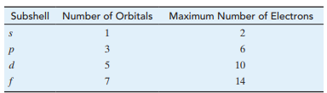

The maximum electron population per shell is shown below.

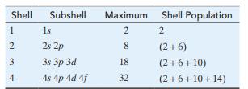

This trend shows that the maximum electron population of a shell is 2n2.

**Writing Electronic Configuration**

Electronic configuration of atoms is the distribution of electrons into atomic orbitals. When atoms are in their ground state, the electrons occupy the lowest possible energy levels:

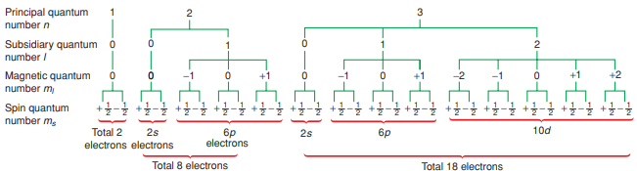

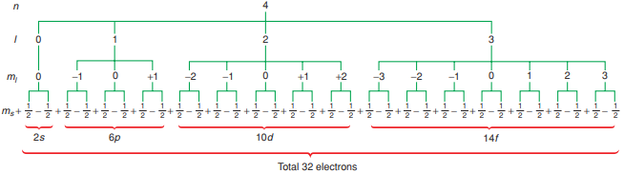

To show the positions of the electrons in an atom, the symbols 1s, 2s, 2p, etc. are used to denote the main energy level and sublevel. A superscript indicates the number of electrons in each set of orbitals. Thus for hydrogen, the 1s orbital contains one electron, and this is shown as 1s1 For helium, the 1s orbital contains two electrons, denoted 1s2 The electronic structures of the first few atoms in the periodic table may be written as shown.

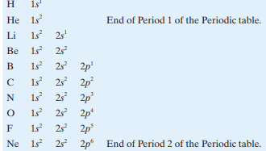

An alternative way of showing the electronic structure of an atom is to draw boxes for orbitals, and arrows for the electrons. By convention, electron spins are represented by arrows pointing up (↑) or down (↓). The orbital diagram for electronic configuration is more beneficial as all the four quantum numbers are represented by it.

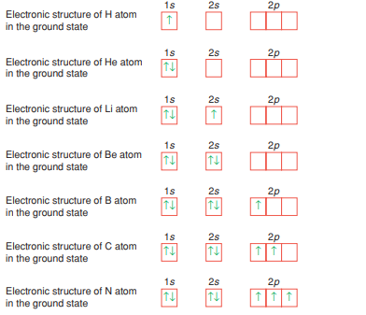

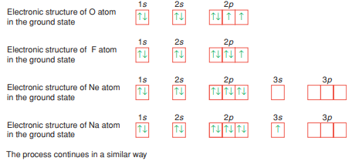

After the 1s, 2s, 2p, 3s and 3p levels have been filled at argon, the next two electrons go into the 4s level. This gives the elements potassium and calcium. Once the 4s level is full the 3d level is the next lowest in energy, not the 3p level. Thus the 3d starts to fill at scandium. The elements from scandium to copper (Note: Cr and Cu have only one electron in the 4s orbital.) have two electrons in the 4s level and an incomplete 3d level, and all behave in a similar manner chemically. Such a series of atoms is known as a **transition series**. A **second transition series** starts after the 5s orbital has been filled, at strontium, because in the next element, yttrium, the 4d level begins to fill up. A **third transition series** starts at lanthanum where the electrons start to fill the 5d level after the 6d level has been filled with two electrons.

A further complication arises here because after lanthanum, which has one electron in the 5d level, the 4f level begins to fill, giving the elements from cerium to lutetium with from one to 14

f-electrons. These are sometimes called the **inner transition elements**, but are usually known as the **lanthanoids** or rare earth metals.

When we consider the chemical reactions of atoms, our attention is usually focused on the distribution of electrons in the outer shell or the **valence shell** of the atom (the occupied shell with the largest value of n). This is because the **valence electrons** (those in the outer shell) are the ones that are exposed to other atoms when the atoms react. The inner electrons of an atom, called the **core electrons**, are buried deep within the atom and normally do not play a role when chemical bonds are formed.

Because we are interested primarily in the electrons of the outer shell, we often write electron configurations in an abbreviated or shorthand form. To write the shorthand configuration for an element we indicate what the core is by placing in brackets the symbol of the noble gas whose electron configuration is the same as the core configuration. This is followed by the configuration of the outer electrons for the particular element. Thus, for sodium and magnesium we write

Na: 1s² 2s² 2p6 3s1

Mg: 1s² 2s² 2p6 3s²

Na: [Ne] 3s¹

Mg: [Ne] 3s²

Even with the transition elements, we need only concern ourselves with the outermost shell and the d subshell just below. For example, for iron with the configuration

Fe: 1s² 2s² 2p6 3s2 3p6 3d6 4s²

The abbreviated configuration is written as

Fe: [Ar] 3d6 4s²

**Explanation for Exceptions in Electronic Configuration in Cu and Cr**

The rules that we have learnt for predicting electron configurations work most of the time, but not always. However, determined electronic configuration of atoms reveals that there are quite a few exceptions to the rules.

For example, two important exceptions are for chromium and copper. Following the rules, we would expect the configurations to be

**Cr. [Ar] 3d4 4s2** **Cu: [Ar] 3d9 4s²**

However, the actual electron configurations, determined experimentally, are

**Cr: [Ar] 3d5 4s1** **Cu: [Ar] 3d10 4s¹**

For chromium, an electron is "borrowed" from the 4s subshell to give a 3d subshell that is exactly **half-filled**. For copper the 4s electron is borrowed to give a **completely filled** 3d subshell.

A similar thing happens with silver and gold, which have filled 4d and 5d subshells, respectively.

**Ag: [Kr] 4d10 5s1** **Au: [Xe] 4f14 5d10 6s1**.

Apparently, half-filled and completely filled subshells (particularly the latter) have some special stability that makes such borrowing energetically favorable. Similar irregularities occur among the lanthanoid and the actinoid elements.

The **stability of half-filled and completely filled subshells** can be attributed to the following two reasons:

1. The half-filled and completely filled shells have symmetrical distribution of electrons, and therefore, are more stable as symmetry is associated with greater stability.





2. When two or more electrons are present in degenerate orbitals of a subshell with the same spin, they tend to exchange their positions. The energy released during this exchange is known as exchange energy. Electronic configurations with half-filled shells permit maximum number of exchanges between electrons of same spin, and thus maximum exchange energy is released which contributes to the stability of the state.



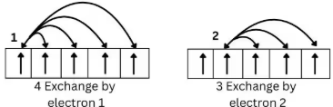

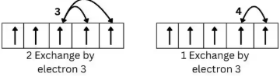



3. In case of Cu, the exchange energy is the same in both the cases. Thus, the stability achieved due to fully-filled and half-filled symmetrical distribution is the main criterion for the exceptional configuration of Cu.

MAGNETIC PROPERTIES

The spin magnetic moment is expressed as:



Substituting ms = (1/2) n, we get the pin only formula as:



Where **n** is the number of **unpaired electrons** and the magnetic moment is expressed in Bohr Magneton. The magnetic moment (μ) can be measured from spin-only formula, which assumes that the magnetic moment arises entirely from the unpaired electron spin. This formula works reasonably well when there is not a significant contribution from the angular orbital moment along with the spin motion. If the species has unpaired electrons, it is **paramagnetic** and if all the electrons are paired, it is said to **diamagnetic**.

**Relation of Colour with Paramagnetic and Diamagnetic Species**

Usually, the paramagnetic species have unpaired electrons which can make transitions and at times these transitions fall into the visible spectra. Thus paramagnetic species usually have colour but it is not true always. Similarly, diamagnetic species are usually colourless, but this is also not true always.

